1. <https://www.youtube.com/watch?v=Vija2TyBLiI>

Index and mapping Creation Part 1 | Elasticsearch Tutorial for beginners | Elk Stack

1. 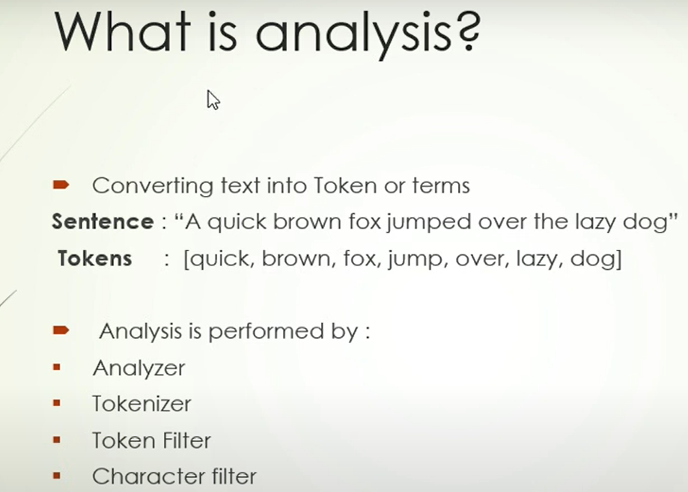
2. 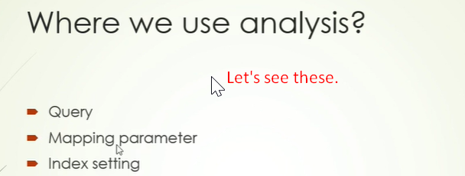
3. 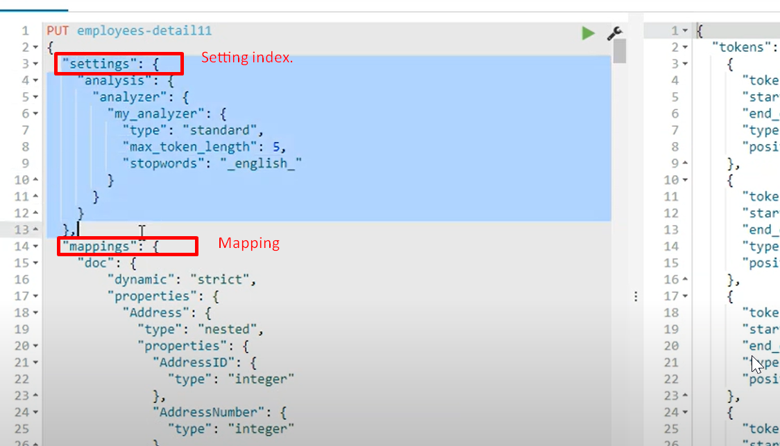
4. 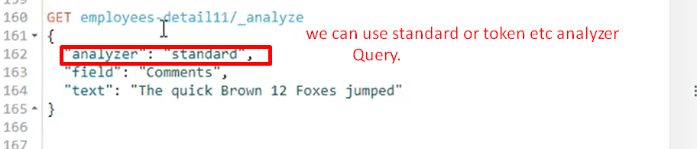
5. 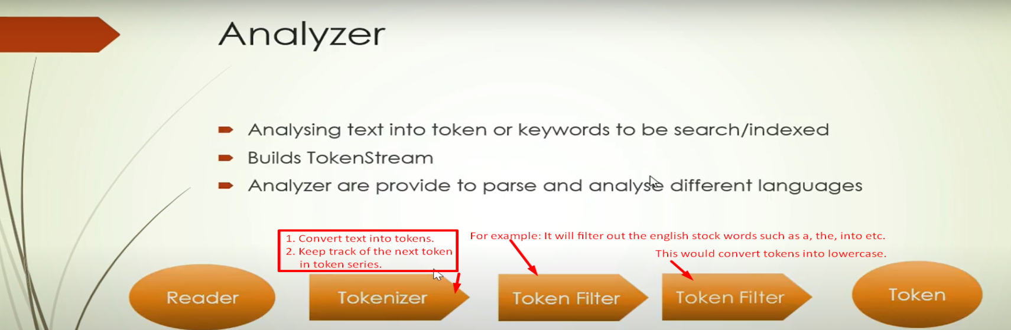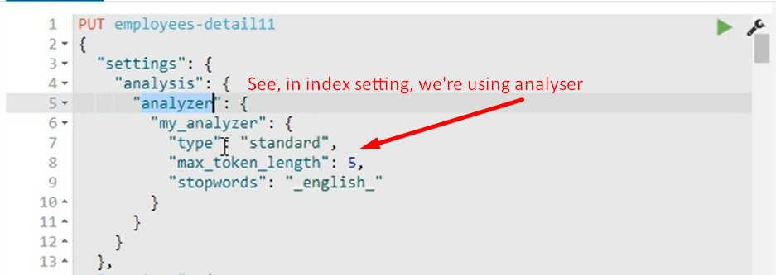

Index and mapping Creation Part 2 | Analyzer in Elastcisearch Tutorial | Elk Stack|

1. 
2. Let’s proceed with the types of analyzers.
3. **Standard Analyzer**:
   1. This is going to perform a query if no other analyzer is specified.